Hello Community Business Leaders:

We are contacting you on behalf of the Robbinsdale Armstrong High School Volleyball Program. Our program typically supports more than 50 players on 5 teams. The district covers certain expenses, such as officials and bussing. However, there are many necessary elements of the sport the school can simply not afford. For example, the school provides for four coaches, but we have been averaging more than 65 players, enough to field five teams. Luckily, through fundraising, we were able to earn enough to provide a stipend for the needed team coaches, providing an opportunity for a dozen more girls to play and represent their high school. (The 2019 teams will be shown at www.armstrongfalconvolleyball.com, our program’s website shortly). The school also gives a small budget for uniforms every three years. This means jerseys are passed down one level every three years. At this point, some of our jerseys have been in commission for more than 10 seasons and over 100 matches. Our fundraising efforts provide uniforms, allow the program to attend a Gopher match, buy balls, nets and other equipment, pay for practice T’s, and cover the cost for players to attend the end-of season banquet. Our girls have sold cookies, sponsor/ work a Freshman tournament, worked races, and volunteered at Second Harvest/ Feed my Starving Children. In addition to these efforts, we are asking for your support.
Any donation you make goes to a wonderful cause in the community and is tax deductible. The Armstrong Volleyball Booster Club is a registered 501c3 organization. The Armstrong Booster Club’s mission statement is, “to help support our coaches and players, and plan fundraising opportunities to raise funds for the development and success of the Armstrong Volleyball High School Program.”
We are pleased to extend an invitation to Community Businesses to work cooperatively with the Armstrong Volleyball Booster Club. The primary benefit from being a sponsor is knowing that you are directly supporting a local high school program that represents your community. Additionally, your sponsorship will earn you the opportunity to promote your business on our website, which gets thousands of hits per year, print recognition in our team booklets, and announced at our varsity home matches. We have several support levels to choose from (listed on the back). Any contribution is welcome and appreciated!
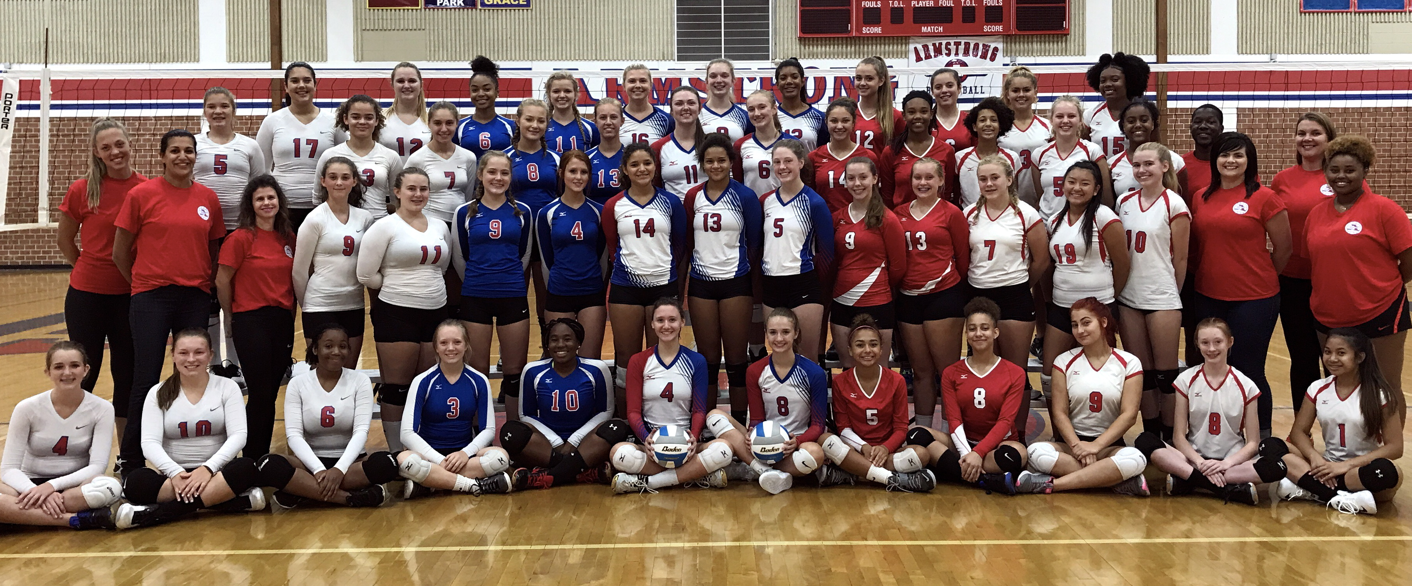

The Armstrong Volleyball Program & Booster Club
Thank you for your support!
- To support this program, select your level of support.
- Mail in your check payable to “Armstrong Volleyball Boosters”. We are a 501(c) 3 organization.
- Your contribution will be tax deductible. Tax ID number is 41-1886793
- Email your business logo (and graphic print ad ready with high resolution jpeg if $300 or above contributor)
- Your business will be listed on our website as an annual sponsor from June 2018 to May 2019

SUPPORT LEVEL | Platinum | Elite Plus | Elite | Gold | Friend
Contribution | $500 or more | $300 | $200 | $100 | $50
Team Thank You letter | X | X | X | X | X
Print recognition in Falcon Volleyball Team Program Booklet with your business listed as a sponsor (and level) | X | X | X | X | X
Home Game announcement of your business sponsorship (and level) during Varsity home games | X | X | X | X | X
Website listing of your business sponsorship (and level) www.armstrongvolleyball.com | X | X | X | X
Business logo and links shown in Falcon Volleyball Team Program Booklet with recognition of your sponsorship (and level) | X | X

PAYMENT  Check payable to:  “Armstrong Volleyball Boosters”  Mail to: Armstrong Volleyball Booster  c/o Carrie Mattila  8825 Bass Creek Ave N.  Minneapolis, MN 55428  Questions, call or text Carrie at (763) 355-2830 | EMAIL  Business Logo & website link if an  Gold, Elite, Elite Plus, or Platinum level sponsor.  Graphic Print Ad ready w/high resolution jpeg if an Elite Plus or Platinum level sponsor.  Email to: Carrie Mattila, Booster Club President, at armstrongfalconvolleyball@gmail.com
_ _ _ _ _ _ _ _ _ _ _ _ _ _ _ _ _ _ _ _ _ _ _ _ _ _ _ _ _ _ _ _ _ _ _ _ _ _ _ _ _ _ _ _ _ _ _ _ _ _ _ _ _ _ _ _ _ _ _ _ _ _

SPONSORSHIP LEVEL: _______________________________ Amount enclosed: $__________________________

Company Name: _______________________________________________________________________________________________

Complete Address:_____________________________________________________________________________________________

Phone: __________________________________________________________________________________________________________

Website: ________________________________________________________________________________________________________

Contact Name: _________________________________________ Email:_________________________________________________

Slogan or Message: _____________________________________________________________________________________________

____________________________________________________________________________________________________________________

